**HACKATHON 3 – DAY 6**

**SAMRA JAMAL**

**DEPLOYEMENT LINK**

**e-commerce-marketplace-ax3hkcwsw-samra-jamals-projects.vercel.app**

**TEST CASE REPORT**

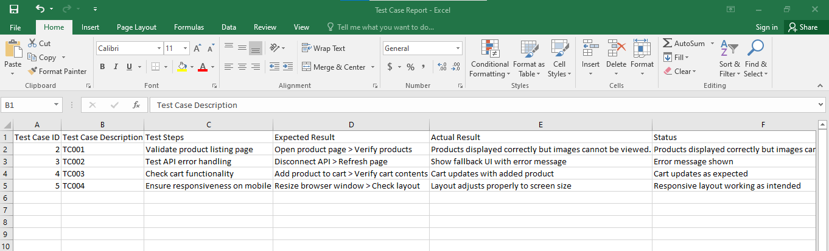

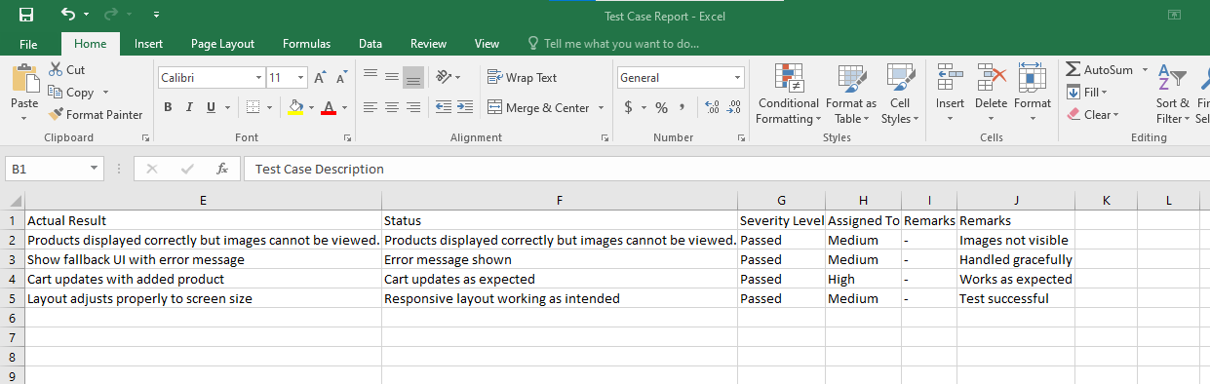

**PERFORMANCE OPTIMIZATION**

**npm install -g lighthouse**

**lighthouse http://localhost:3000 –view**

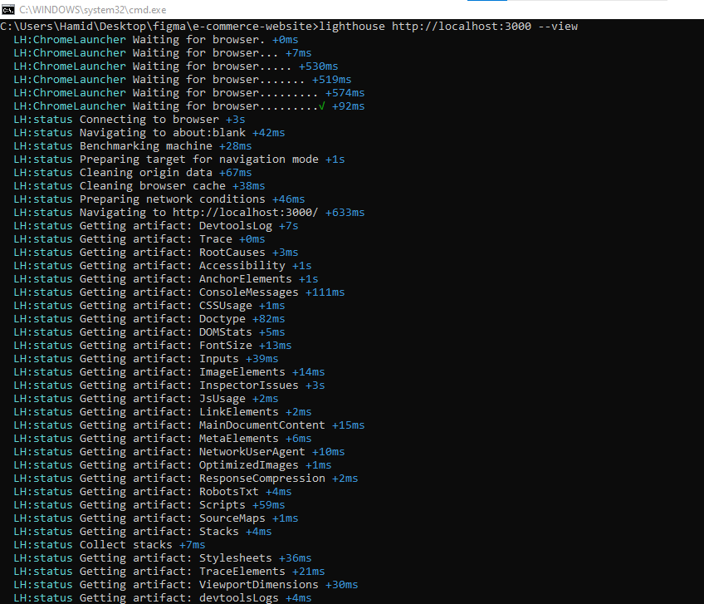

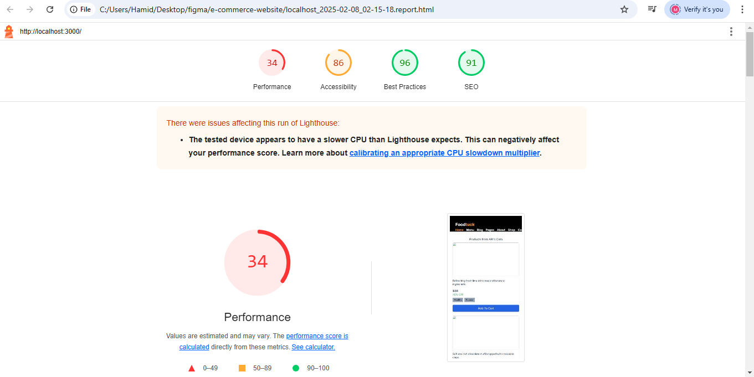

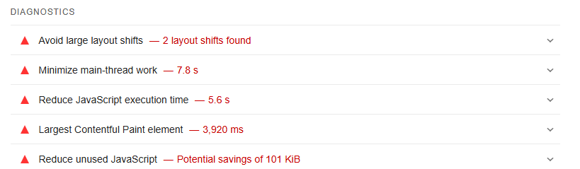

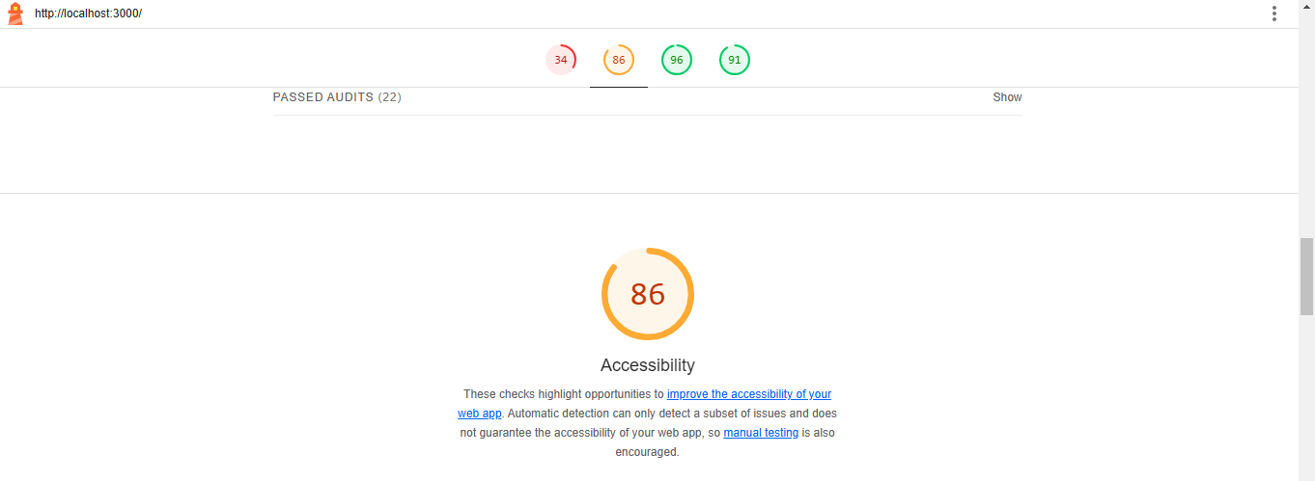

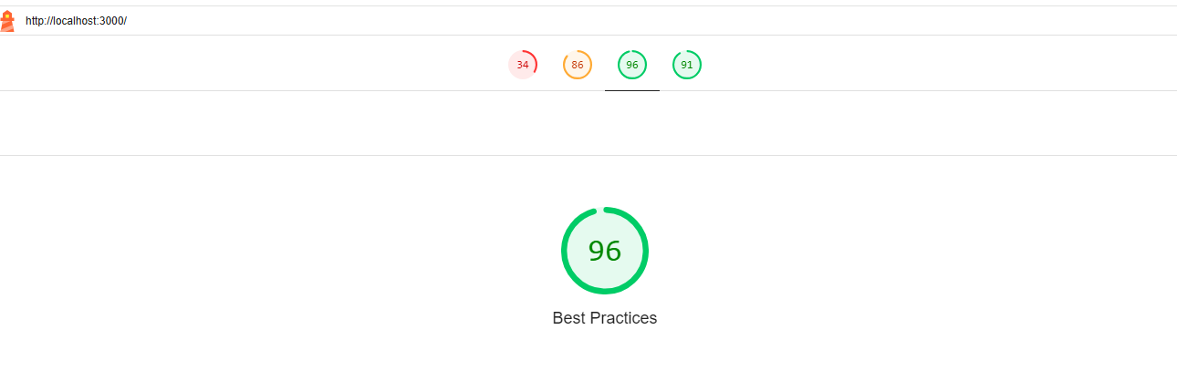

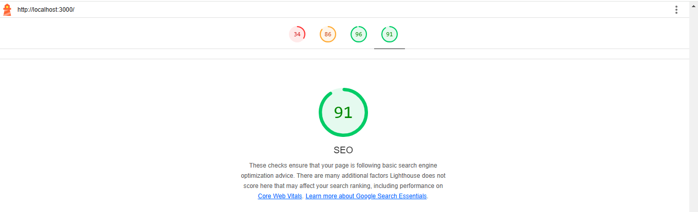

**DEVELOPER RESOURCES**

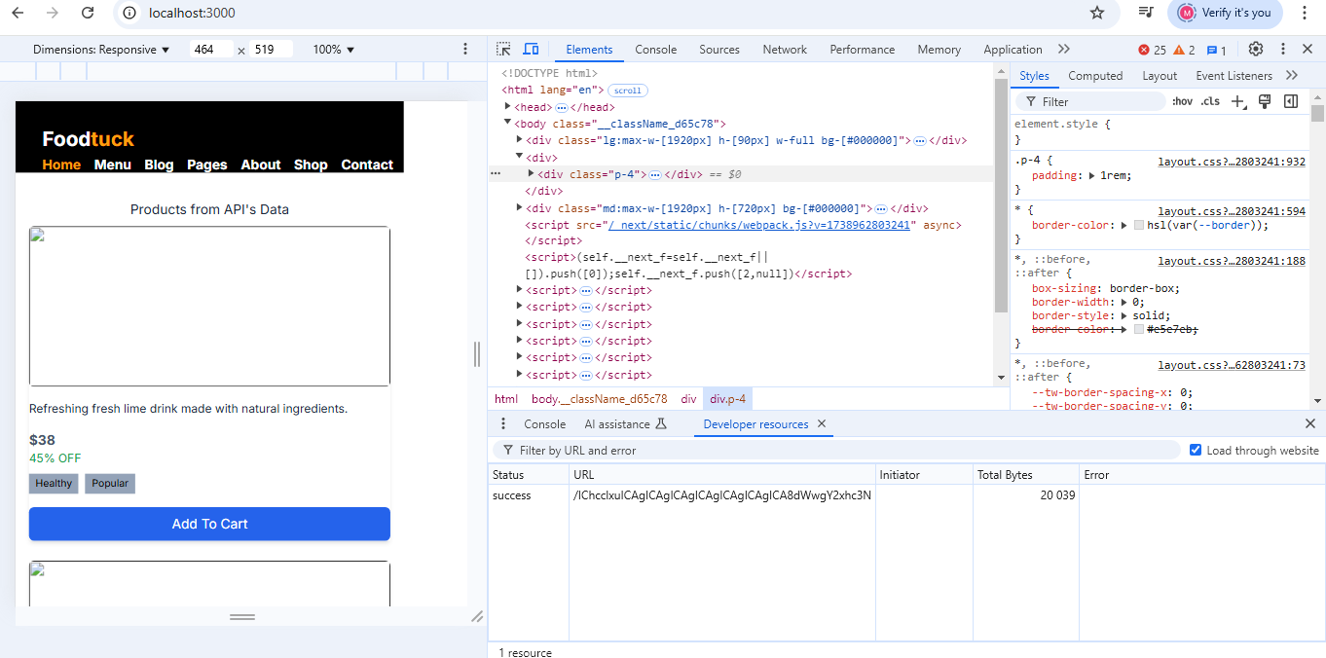

**PERFORMANCE MONITOR**

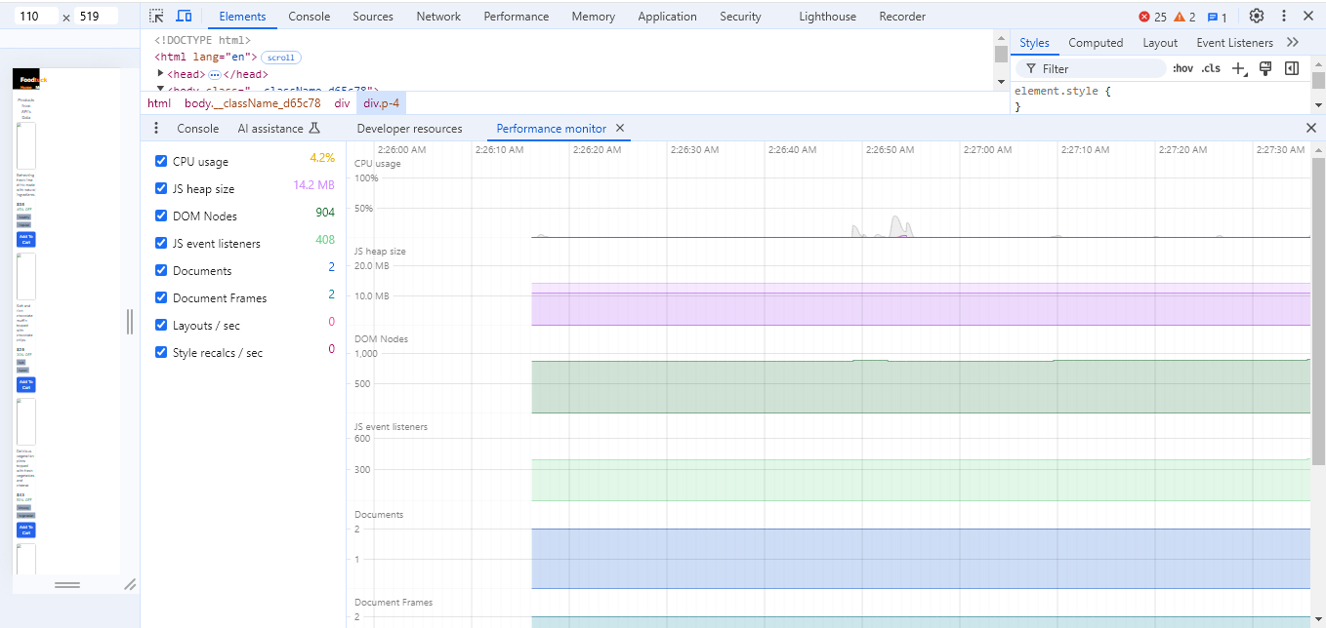

**SECURITY OVERVIEW**

